



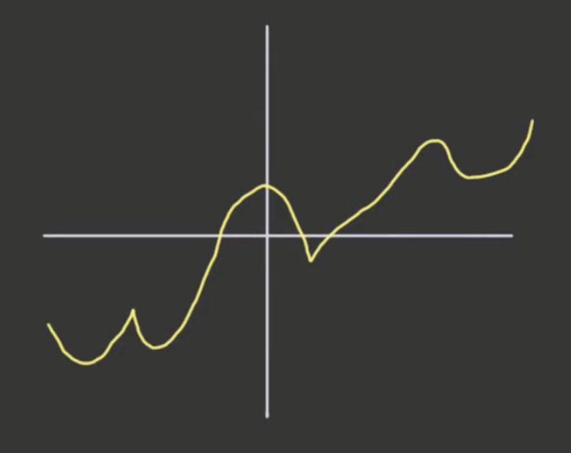

* No holes or jumps

Basic functions that are continuous everywhere:

1. Constant functions

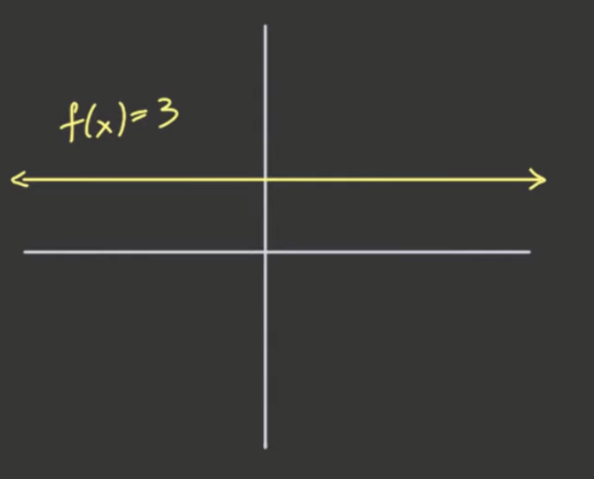

1. g(x) = x

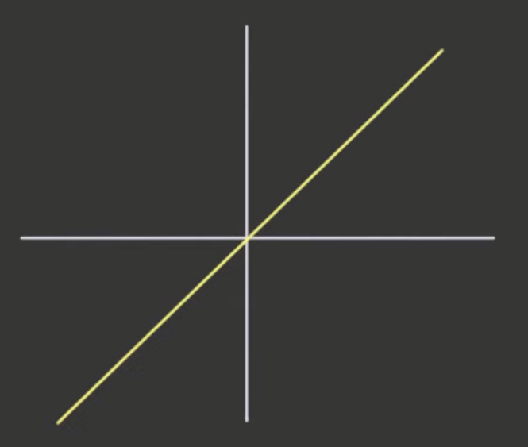

1. |x| (abs functions)

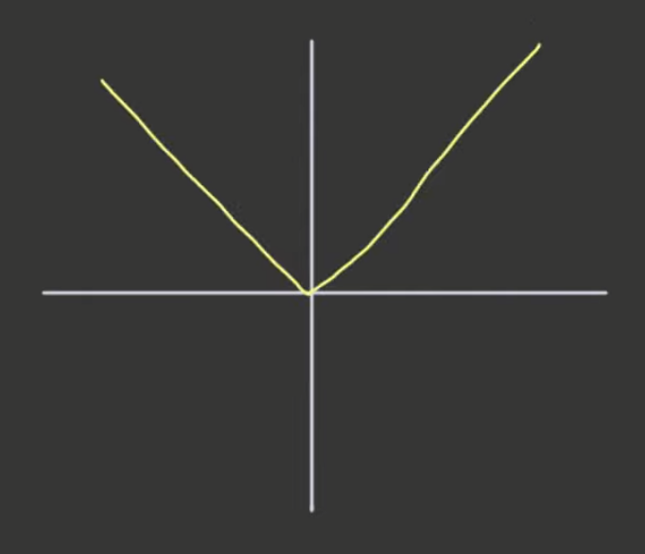

1. sin(x)

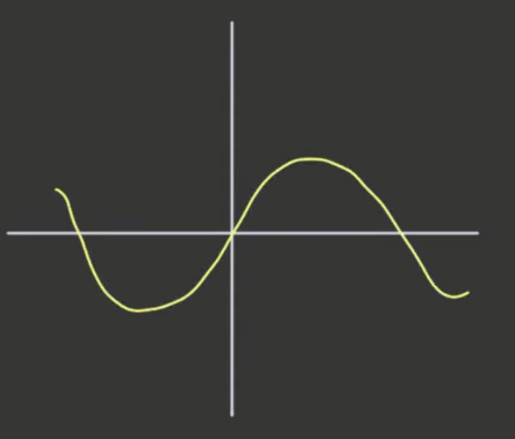

1. cos(x)

Note:





* cos (x) cannot be zero, so there is no solution if cos(x) will equal to zero
* this will have discontinuity!

Examples/Questions

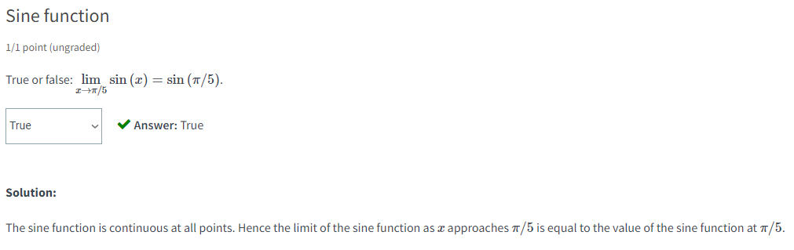

* if function is continuous, limit of f(y) as y approaches x = f(x)

